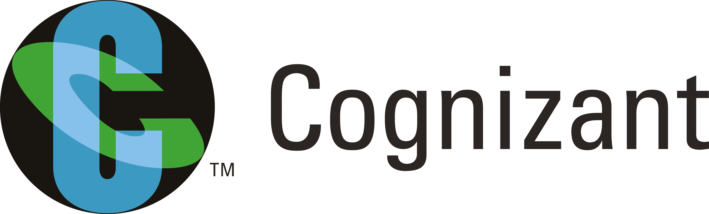
#505/1A, 3rd Street, Muninanjappa Layout,
Near Ramamurthy Nagar Old Police Station,
Bangalore – 560016.

Tel: +91 87625 39371
Email: cselakshmanan@gmail.com

https://bhuvaneshwarank.github.io

Bhuvaneshwaran K

Availability | 2 Month
Nationality | Indian
Qualifications | Bachelor of Engineering in Computer Science (2011 – 2015)
IT Skills | Python, Flask, Scikit-Learn (Text Classification Problems), NLTK, Chat Bot development using IBM Watson Conversation, Microsoft LUIS, Amazon LEX, Wit.AI, Dialog flow, Analytics tools like IBM Watson Analytics, Microsoft Azure ML, Amazon AWS and Bluemix hosting.
Summary | Data Scientist with 3 years of experience in high level data analytics in both exploratory and predictive modeling’s mainly using open source technologies. Found automation opportunities in all business environments to reduce its cost factor by ~30%. Able to mine hidden gems located within large sets of different data.  Able to handle and develop products (POC and Production ready) in a full stack way (Both UI and Backend) independently. Capable of turning raw data to a profitable outcomes to the company applying cognitive automation. Easily collaborate with big teams to support and help company to the best level.

Employment History:

Company : Cognizant Technology Solutions Pvt. Ltd., Bangalore

Position : Data Scientist (Machine Learning Architect)

Duration : Jan 2016 to Present

About Company
- Cognizant is an American multinational corporation that provides IT services, including digital, technology, consulting, and operations services. It is headquartered in Teaneck, New Jersey, United States. Cognizant is included in the NASDAQ-100 and the S&P 500 indices. It was founded as an in-house technology unit of Dun & Bradstreet in 1994, and started serving external clients in 1996.
Projects
Agent Assistant Bot
- AI Chat Bot designed and developed for US Based Life Science Company to assist L1 agents in call center to identify correct L2 agents using caller inputs.
Technology Used
- Python – Flask, Sqlite DB, AIML, Microsoft IIS
Achievement
- Achieved ~95% accuracy in identifying correct reps.
- Turnaround time reduced from 6 min to 2 min for each call.
- Lead the project end to end and completed before the deadline.
FAQ Business Bot
- AI Chat Bot designed and developed for US based Manufacturing company to assist users in their FAQ’s or rise a service ticket directly if any out of scope queries are found.
Technology Used
- ServiceNow, Python – Flask, PostgreSQL DB, AIML
Achievement
- Nearly 98% queries are handled by Bot itself remaining 2% Bot will create a service ticket for handling by human agents.
- Users are very much interested in using AI Bot and more productive for handling frequent issues.
- Worked as Machine Learning architect and handled 3 trainees under me in that team.

Company : Sri Shanmugha Educational Institution, Salem

Position : Technical Trainer

Duration : May 2015 TO Jan 2016
About Company
- Sri Shanmugha Educational Institution is to provide quality education and enables the students to excel in the field of their choice. The institution facilitates them to become skilled in technology, analyze the concepts and apply it for the real benefits which also ensures them to become confident and competent in Engineering and Technology.
Role
- Technical Trainer
- Train students in programming languages like Java, Python and PHP. Mostly in Android application development and learning new approaches for old problems.
Technology Teached
- Python, Android Development using Java
Achievement
- Achieved more than 80% placement in that academic year.
- In python technology alone around 20 students out of 49 were placed.

